**BUSINESS PLAN**

**Version 09.26.2019**

Confidential Draft – For Discussion Purposes Only

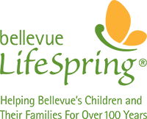

**INTRODUCTION** Bellevue LifeSpring’s mission is to foster stability and self-sufficiency for Bellevue’s children and their families through programs that provide food, clothing, education and emergency assistance.

We envision a Bellevue where the basic needs of all children are being met so they can focus on their education and break the cycle of poverty in our community.

This plan details our efforts over the next five years to ensure that students in Bellevue have the food, clothing, housing assistance and educational support they need to achieve and graduate at the same rate as the rest of the student body by 2025

**CHALLENGE** Many are shocked to discover poverty exists in Bellevue. Along with the entire Puget Sound region, Bellevue has experienced rapid growth over the past several decades. Steep increases in the cost of living have accompanied this growth and created challenges for many families in the region whose household income has not kept pace.

To determine its low-income population, the Bellevue School District uses the [Federal Free](https://www.govinfo.gov/content/pkg/FR-2019-03-20/pdf/2019-05183.pdf) [and Reduced Price Lunch (FRL) Program](https://www.govinfo.gov/content/pkg/FR-2019-03-20/pdf/2019-05183.pdf) guidelines. A family of four qualifies for reduced prices with an annual income of approximately $47,000 and qualifies for free meals with an annual income approximately $33,000. However, according to the latest income level analysis from the [U.S. Department of Housing and Urban Developmen](https://www.huduser.gov/portal/datasets/il.html)t (HUD), a family of four living in Bellevue now needs to earn over $88,000 to cover its most basic needs.

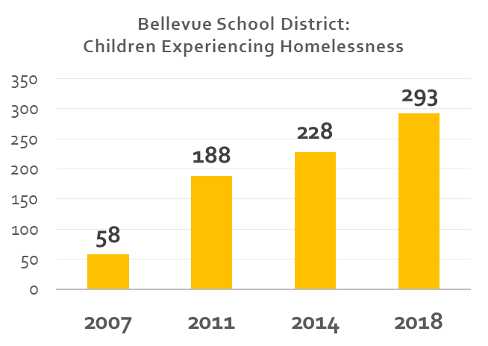Based on this FRL criteria, today more than 3,600 children in Bellevue are living in poverty and approximately 300 are experiencing homelessness. Based on HUD criteria, the number of families struggling to meet their basic needs is even higher.

No neighborhood in the city is immune. As of October 2018, every school in Bellevue serves low-income children, representing a

total of 18% of the student body. The numbers range from 1% (5 students) at the

least-impacted school to 55% (267 students) at the most-impacted. Of the 28 schools in Bellevue, 26 have students experiencing homelessness.

When a student does not have housing stability or adequate nutrition, there can be a negative impact on their overall academic performance and personal well-being. A 2013 study found that poverty can cost children 13 IQ points creating further challenges to breaking the cycle with education. (Source: *Poverty Impedes Cognitive Function by Mani, Mullainathan & Zhao, Science, August 2013.)*

Less than half of Bellevue kids who are enrolled in the federal free and reduced price lunch (FRL) program are meeting achievement standards. Low-income children in Bellevue are experiencing achievement gaps of 35% in reading and 49% in math.

While the Bellevue School District had an overall four-year graduation rate of 95% in 2018, just 91% of low-income students graduated in five years. That number drops to 81% for students experiencing homelessness. That’s a total of at least 65 low-income high-schoolers that didn’t receive their diploma.

As many as 78% of the high school students in need of credit recovery come from

low-income families. Even with subsidies, the average cost of a summer class is over $160. The students most in need of support to graduate are also the least likely to be able to afford the tuition for the class. **Bellevue LifeSpring’s programs have already proven to have an impact.** In 2018, our summer school and credit recovery program ensured 46 students, 3% of the graduating class, earned their diplomas.*

Children experiencing hunger are more likely to be absent and tardy, in addition to having behavioral and attention problems more often than other children. They are more likely to have repeated a grade, received special education services, or received mental health counseling than low-income children who do not experience hunger. Homelessness is associated with an 87% likelihood of dropping out of school. **

While Bellevue carries a regional reputation for affluence, the growing impacts of poverty are being felt throughout the city.

# DATA

**SOURCES** * Student data in this plan are sourced from Bellevue School District 2018-19 enrollment demographics and Washington State Office of Superintendent of Public Instruction.

** Information presented by Bellevue School Superintendent Dr. Ivan Duran at the Bellevue LifeSpring Annual Luncheon, 2018.

**OUR HISTORY** Bellevue LifeSpring was established in 1911 as the Overlake Service League on Hunts Point.

It was founded on the philosophy of “neighbors helping neighbors.” In the beginning, women delivered food baskets, goats for milk and seeds and farm equipment to plant and harvest food. By the time Bellevue was incorporated as a city in 1953, Overlake Service League had been supporting families in the Bellevue area for nearly 42 years. By the end of the decade, it was serving more than 200 individuals per year.

As Bellevue grew, so did the need. In 2011, Overlake Service League celebrated 100 years of serving the Bellevue community with a Centennial Gala and changed the name of the organization to Bellevue LifeSpring to better reflect its commitment to serving families within the Bellevue School District.

With the support of its Board of Directors, Circle members, volunteers and donors, Bellevue LifeSpring now serves more than 2,000 children per year. Bellevue has grown, and we continue to grow with it, expanding our century-old tradition of neighbors helping neighbors.

**OUR APPROACH** While there are many organizations in the region that address aspects of child poverty and housing insecurity, Bellevue LifeSpring is the only organization that provides this collection of direct and comprehensive services exclusively to families with children living in Bellevue.

We do not require families to complete burdensome amounts of paperwork with long waiting periods to get help. We follow federal income guidelines to determine assistance and qualifications are simple and straightforward:

* Income is 200% or lower than the federal poverty line ($51,500 for a family of four)
* Must currently live in Bellevue or within Bellevue School District
* Must be able to show proof of financial need.
* Must have children (under 18) currently living in their household.
* Must not have violated program guidelines within one year of service.

Rarely, we make exceptions for families above that level if they can provide documentation of financial need (for example, excessive medical bills).

For example, the typical client that receives rental assistance has an average monthly income of $1,890. Nearly 70% are single parents with an average household size of 3.5. They are ethnically diverse: 28% Hispanic/Latino, 22% White, and 20%

Black/African-American.

Our bilingual staff is responsive, inclusive and compassionate and welcomes any family that walks through its doors at its Bellevue Square office. We operate on a first-come,

first-served basis. If we cannot provide the assistance they need, we connect them with other community resources that can. We are proud to report that in 2018 we did not turn away a single qualifying client.

# OUR

**PROGRAMS** We have evolved our programs to stay relevant to Bellevue’s changing population. We provide comprehensive services to support children’s basic needs and to allow them to pursue their educations.

The long-term benefits that follow education – employment and reliable income - break the cycle of poverty.

## Comprehensive Solutions Complement Family & Community Supports

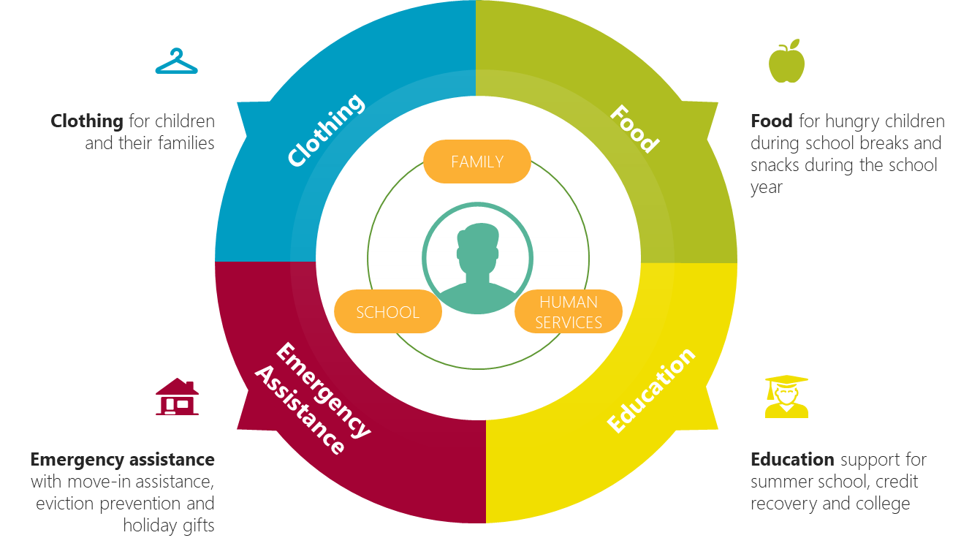

We have a solid track record of consistently providing these services to our growing population.

## Historical Service Rates: 2012-2018

|  |  |  |  |  |  |  |  |  |
| --- | --- | --- | --- | --- | --- | --- | --- | --- |
| ***2012*** | | ***2013*** | ***2014*** | ***2015*** | ***2016*** | ***2017*** | ***2018*** | ***Total*** |
| *School Break Food (Students –duplicated)* | 2,534 | 4,856 | 4,856 | 4,719 | 5,813 | 6,245 | 7,011 | 36,034 |
| *Clothing (Students)* | 353 | 444 | 220 | 430 | 458 | 512 | 512 | 2,929 |
| *Thrift Shop Assistance (Individuals)* | 131 | 62 | 136 | 103 | 91 | 73 | 86 | 682 |
| *Education Grants* | 13 | 20 | 16 | 16 | 20 | 26 | 26 | 137 |
| *Summer & Credit Recovery (Students)* | 24 | 24 | 137 | 153 | 169 | 203 | 192 | 902 |
| *Rental Assistance*** (Families)* | 150 | 49 | 51 | 48 | 53 | 34 | 54 | 439 |
| *Emergency Food Assistance (Families)* | 134 | 126 | 342 | 74 | 84 | 75 | 113 | 948 |
| *Holiday Adopt-a-Family (Individuals)* | 811 | 1,484 | 1,958 | 1,956 | 2,108 | 1,423 | 1,487 | 11,227 |

***In 2013 we began covering a full month of rent.

We want to take this support to the next level – serve all low-income children and ensure the long-term impact to their education and future stability and self-sufficiency.

# ORGANIZATIONAL

**SUPPORT** Bellevue LifeSpring is supported and managed by a 23-member Board of Directors, a five-member Emeritus Council, and hundreds of volunteers and donors.

We also have established a close, long standing partnership with the Bellevue School District to ensure programs are deployed efficiently with direct impact on improving student achievement in mind. Family Engagement Specialists in the schools are a primary referral source for our clients, and the district shares achievement data to measure progress.

We have a powerful base of support in our membership Circles that began over 100 years ago. These groups provide not just financial, but volunteer and community engagement support as well. We currently have nine Circles with more than 250 total members:

*Clemmie Evans Circle Downtown Circle Enatai Circle Fairweather Circle*

*Hunts Point Circle Kemper Freeman Circle One Circle*

*Yarrow Point Circle Youth Council*

We are actively seeking to diversify this membership base with initiatives including the newly formed Youth Council, Circle expansion efforts in new neighborhoods, and Circles based on employer or affinity groups.

The ethnic diversity of Bellevue has grown significantly. Currently more than 38% of Bellevue public school students speak English as their second language and more than 98 different languages are represented across the District. Spanish and Mandarin are the two most popular first languages. We want to ensure that our Circles reflect this growing regional diversity. By keeping our Circle membership relevant to the changing needs of Bellevue, we will better reach these communities with coordinated outreach efforts.

**SOLUTION** Working side-by-side with the Bellevue School District, we envision a Bellevue where all children can focus on their education because their basic needs are being met. We want to break the cycle of poverty in our community.

**Our Goal:** Ensure that all students in Bellevue have the food, clothing, housing assistance and educational support they need to achieve and graduate at the same rate as their peers by 2025.

**Our Strategies:** In order to reach ALL children living in Bellevue, we will:

* Support every child’s basic needs – food, clothing and housing assistance – over the long term, focusing on those that qualify for the Federal Free & Reduced Price Lunch program.
* Fund summer school and credit recovery programs for high schoolers.
* Be the voice for children and their families in Bellevue.

Our initiatives are focused on building relationships and partnerships with both our clients and the community. In parallel, we’ll be a strong advocate for families in Bellevue living in poverty to both build awareness and generate resources to support them.

Ultimately, we want to ensure Bellevue’s children graduate from high school and are set up for a stable future to become self-sufficient. For every child that doesn’t graduate from high school, there is an economic burden of nearly $1 million to the state. (Source: *The Economic Value of Opportunity Youth* by Belfield, CUNY; Levin & Rosen, Columbia University; January 2012)

The cost to support children now is relatively small, but the impact is large and enduring for the whole community. Our services save the state in the long-run by breaking the cycle of poverty and reliance on government support. Furthermore, as we grow, a larger and larger portion of our budget will be devoted to program expenses as we improve economies of scale.

We have a track record of setting and hitting our growth targets. In the past five years, our operating budget nearly doubled from $1.2 million to $2.1 million. We plan to double our impact again in the coming five years.

To achieve our ambitious goals, we need to increase our annual operating budget from $2.1 million to $4.2 million in five years. The payback for Bellevue is both stable families and a potential $65 million savings in state resources.

**INITIATIVES** Six key initiatives will drive Bellevue LifeSpring’s activities in 2019-20 and beyond.

**Client Service Objective 1:** Develop, maintain and measure long-term client relationships (versus one-time transactional handouts).

Our current programs are developed to provide support for basic services, but they are transactional and often offered in a once-at-a-time nature. For example, we provide emergency rent assistance to prevent a family from getting evicted and experiencing homelessness, but we don’t track or follow up on their progress or ongoing needs.

Now, by investing in both systems and staff that allow us to follow up with our clients, we’ll be able to understand what families need to remain stable. Using this data, we can then evolve our programs to meet their needs and increase the impact our support is having on educational outcomes and stability for those we serve.

**2019 Q3** Develop protocols and timelines for client follow-up.

Align metrics with Family Engagement Specialists at the Bellevue School District.

**2019 Q4** Develop a system to track and monitor client assistance activities.

Increase Human Services Administrator staff capacity to conduct follow-up.

## Metrics:

* # and type of client interactions
* Coverage of programs across neighborhoods and schools
* Cost per client served
* Change in key indicators (attendance, achievement gap, behavior, graduation)

**Presence Objective 2:** Go to where our clients are with face-to-face, in-person outreach.

Currently we rely on referrals from school family engagement specialists and case managers in other regional social services agencies, but we know we’re not reaching everyone that needs our help.

In order to broaden our reach, we’ll build a stronger presence in the neighborhoods and schools where the children need our help. In addition to schools, we will add community centers, neighborhood-based events, churches and mosques. Our staff will work with volunteers and Circle membership to host these events as hands-on volunteers and Ambassadors. A formal Ambassador program will support this effort, while providing Circle members with community engagement opportunities in the tradition of “neighbors helping neighbors.”

**2019 Q3** Identify client outreach targets and develop communications plan.

Create a Circle Expansion Committee and set goals for Circle expansion efforts.

**2019 Q4** Augment staffing to coordinate Ambassador volunteer opportunities.

Develop Ambassador Orientation materials, training and schedule.

**2020 Q1** Train Ambassadors and host events.

**2020 Q2** Refine approach and materials with feedback from staff and Ambassadors.

## Metrics:

* Geographic and demographic reach of engagement activities
* # of Ambassadors recruited, trained, and retained
* Number of clients served

## Corporate

**Partnership Objective 3: Formalize and build our corporate partners.**

Bellevue is a hub for regional businesses – Microsoft, Amazon, Eddie Bauer, PACCAR, Concur, Smartsheet, are the tip of the iceberg. Our programs offer rich opportunities for local engagement that directly impact employees where they work and live. We will start with community-level corporate sponsorship levels to deepen investments from Bellevue’s business community. We will also explore the idea of creating workplace-affiliated membership Circles and ongoing meaningful volunteer opportunities.

**2019 Q3** Map potential corporate partners and build a cultivation pipeline.

**2019 Q4** Develop corporate sponsorship packages.

Explore opportunities for corporate volunteerism with Bellevue School District.

**2020 Q1** Conduct face-to-face meeting with corporate prospects.

**2020 Q2** Launch first corporate-affiliated membership Circle.

## Metrics:

* # of contacts with major employers in Bellevue
* # and size of corporate sponsorships
* # of corporate-affiliated membership Circles

## Policy

**Agenda Objective 4:** Partner more closely with the city and county on issues that impact our clients.

We have strong relationships with local City of Bellevue officials and our County District Representative, but we do not yet have an articulated advocacy agenda that could drive productive partnerships with local agencies. With a defined agenda, we can also mobilize our Circle members and corporate partners to become advocates for key issues.

Bellevue LifeSpring is a natural leader to galvanize the city around key issues impacting our clients:

* Affordable housing development for Bellevue’s working families
* Regional transitional facilities to support families without permanent homes
* Adequate nutrition for all Bellevue’s children
* Public investments to close the achievement gap in our schools

Furthermore, our clients are increasingly being impacted by local and regional legislative actions, such as changes in eviction notification timelines and new state scholarship grants. It is crucial that we stay abreast of issues that may impact our clients and communicate the potential impacts of these changes on their lives. Close relationships with local government officials will facilitate communication of these changes to our low-income clients.

**2019 Q3** Develop draft advocacy agenda.

**2019 Q4** Meet with regional stakeholders to test scope and refine advocacy issues.

**2020 Q1** Create communications and training materials to activate corporate partners and Circle members.

**2020 Q2** Attend face-to-face meetings and events to advocate issues for low-income families.

## Metrics:

* Contacts with Bellevue City Manager, Mayor, Deputy Mayor and Council and King County District Representative and staff.
* Local government funding for Bellevue LifeSpring programs.

**Thrift Culture Objective 5:** Analyze Thrift Culture contribution margin to determine future operations and strategies.

As the longest tenant in the Bellevue Collection, the thrift store is a community institution and the foundation of our longstanding relationship with Kemper Freeman and the Kemper Freeman family.

Thrift Culture serves four important roles: 1) generates earned income from sales; 2) builds community and awareness through the store; 3) provides a service to clients in need of clothes and household goods through a voucher program for low-income families, and 4) provides engagement opportunities for volunteerism.

We have employed an experienced retail manager and recently have installed a new point-of-sales data collection, which we will use to analyze sales and client trends and determine strategies for the store moving forward.

**2019 Q3** Develop cadence of stand-alone financial reporting and sales forecasting. Explore and test options for implementation of an online sales platform. Implement a volunteer recruitment and training program.

Pilot high-end collection program with Bellevue Square.

Continue to deepen relationships with Kemper Development staff to leverage their marketing and relationships with merchants to support our shop.

**2019 Q4** Implement online sales platform.

Review POS reports to evaluate, then adjust pricing and marketing strategies. **2020 Q1** Analyze POS data for trends in voucher usage by Bellevue LifeSpring clients. **2020 Q2** Develop additional plan for ongoing Thrift Culture operations.

## Metrics:

* Revenue generated
* Volume & quality of donations
* New volunteers recruited & shifts covered
* Clients served
* Online sales

**Revenue Team Objective 6:** Build a Partnerships & Investments team to grow community and financial support.

A major aspect of our growth strategy is to diversify revenue sources through targeted partnerships and relationship building (corporate, foundations, agencies and individuals). The Partnerships & Investments Director will lead this effort working with the Executive Director. We will explore utilizing a grants prospecting firm and contracting for events management as this transition occurs.

Efforts to diversify board membership and engagement through the ongoing refinement and testing of the business plan with community stakeholders will be part of this process.

**2019 Q3** Hire and onboard Partnerships & Investments Director.

Develop fundraising roles, responsibilities, goals, and pipeline management process for staff and board members.

Through the Governance and Board Development Committee, audit specific board capabilities and identify areas for skills and background diversification needed through a board development recruitment matrix.

**2019 Q4** Conduct 30 personal conversations with major current supporters and prospective investors per month to review and test the business plan. Develop program-based Advisory Committees (i.e. Nutrition Advisory Committee) to provide opportunities for partner and community engagement beyond board membership.

**2019 Q4** Complete grant prospecting review for foundations and government agencies.

**2020 Q1** Schedule exploratory meetings with at least five new foundations or agencies.

## Metrics:

* Recruitment and retention of key hires and board members.
* Increase funds raised by $300,000 by the close of 2019-20 fiscal year.
* Cost per dollar raised at $0.30 by beginning of 2020-21 fiscal year.
* Revenue growth target of 15% per year.

The following table summarizes the strategies, initiatives and key performance indicators we will use to monitor our impact and progress:

## Program Impact Model

|  |  |  |  |
| --- | --- | --- | --- |
| **Strategy** | **Initiative** | **Lead KPI** | **Lag KPI** |
| Basic Needs | Long-term relationships | # Clients served | Attendance rates |
|  | Face-to-face outreach | Unit cost per client | Achievement gap |
|  | Thrift store | Neighborhood saturation % | Behavior |
|  |  | Service population demographics |  |
|  |  | # Volunteers vs. need |  |
|  |  | Thrift store clients served, donations, sales |  |
|  |  |  |  |
| Summer School and Credit Recovery | Long-term relationships | % of population served | Graduation rates |
| Advocacy | Build corporate partners | # contacts with major employers in Bellevue | Corporate funding |
|  | Focused government relations: city and state | # contacts with public officials | Public funding |
|  | Raise money | # contacts with individual donors | Cost per dollar Raised |
|  |  |  | Member Circle expansion |

**MARKETING** Our marketing activities address five different target audiences, each requiring a unique approach:

1. Clients
2. Program Partners (including school staff and caseworkers from agencies helping to identify and serve clients)
3. Business Partners
4. Government Partners
5. Individual Investors

During the first year, existing events will continue to be community-building “Friend-Raising” events that support the fundraising activities of the organization.

Activities and the target audiences they address are summarized in the following table:

|  |  |  |  |  |  |
| --- | --- | --- | --- | --- | --- |
|  | **Clients** | **Program Partners** | **Business Partners** | **Government Partners** | **Individual Investors** |
| **Website & Social Media** | X | X | X | X | X |
| **Community Outreach** | X | X | X | X | X |
| **Luncheon** |  |  | X | X | X |
| **Uncork the Night** |  |  | X |  | X |
| **Media Relations**  (incl. *Points Living)* | X | X | X | X | X |
| **Face-to-Face Meetings** |  | X | X | X | X |
| **Direct Mail & Email** (Newsletters, Annual Reports, Impact Reporting) |  | X | X | X | X |

**Marketing metrics** will be tied to several of the 2019-20 strategic initiatives outlined earlier in this document, including stakeholder engagement and activation, revenue growth, and cost per dollar raised.

# REVENUE

**DOMAINS** Bellevue LifeSpring’s growth will be fueled by a diversification of revenue sources. Current activities are funded primarily by individual donations through events and several small local grants. Initially, we’ll focus on corporate and individual investor contributed revenue, and test the waters of larger grants and local government funding.

Individual Investments: Individual charitable gifts are currently solicited primarily via fundraising events and some direct communications. The Partnerships & Investments Director will provide close relationship management of individuals with the financial capacity to make 5- to 6-figure investments. With our track record, strong management, a compelling plan, and clear accountability, we can offer high-net-worth individuals a compelling charitable investment with a social return on investment that directly benefits their Bellevue community. At maturity, we expect each Partnerships & Investments Officer to manage a $1 million portfolio of relationships.

Business & Corporate Partnerships: Corporate partnerships can generate powerful employee engagement and company loyalty and foster corporate social leadership. For example, instead of a symbolic volunteer day for a company, we can offer long- term community relationships through workplace Circles. Closer corporate relationships will provide significant support for our programs and help drive results. Companies can be natural partners in community-based advocacy issues as well.

Earned Income: Thrift Culture sales will continue to be a contributor with earned income and development of an online sales platform.

Foundation Grants: We have made significant inroads with smaller grantmakers and local family foundations, but there remain untapped revenue sources with other grantmakers. We will align our program initiatives with foundation opportunities with thorough grant prospecting.

Government Funding: Given the typical restrictions of state and federal funding, we have not pursued revenue at these levels. However, our programs are particularly well-suited to regional investment of city and county funds, which we have begun to explore. We will continue to explore grant opportunities with the County and will need to wait for the next City budget cycle. Both the City of Bellevue and King County are currently in a 2019/20 budget cycle. The next opportunity to apply for City funding will be March 2020 for the 2021/22 budget.

**FINANCIALS** Five-year financial projections are attached.

## Revenue Assumptions:

* *Events will continue to be the primary revenue driver in 2019 until a full investments pipeline is activated. Uncork the Night will evolve into a major donor celebration event rather than a primary fundraiser.*
* *Circle growth produces a modest increase in Circle and Community-based revenue.*
* *Thrift Shop income will remain stable with modest increases from online sales.*
* *Bellevue LifeSpring will explore sources of local government funding.*

## Expense Assumptions:

* *The ratio of program expenses across assistance areas are projected based on 2019 allocations. These may be adjusted based on data on program efficacy and efficiencies of scale.*
* *The average cost to provide a child with Bellevue LifeSpring’s wraparound services for one year was $1,528 in 2018. This plan assumes doubling the reach of programs over the 5-year period.*
* *Competitive compensation will support staff retention and new hiring.*
* *Current office space can accommodate staff growth plans.*
* *Events management will be contracted on an as-needed basis.*
* *Thrift store will continue to be primarily staffed and supported by volunteers.*

**TEAM** Our leadership team contributes broad and deep experience in Bellevue:

**Staff**

**Jennifer Fischer, Executive Director,** has led us for five years with her extensive background in corporate and membership development, relationship building, event marketing and advertising. As the former Vice President of Sales and Marketing for the Bellevue Downtown Association, she directed sponsorship sales and marketing and built a strong relationship base in Bellevue. She also served as Seafair’s Director of Marketing and Sponsorships. She was also a member of the Puget Sound Marketing Association and Visit Bellevue Washington Advisory Committee.

**Board of Directors**

**Joseph Brazen**, Brazen Group Properties, 520 Bar & Grill, Central Bar + Restaurant

**Julie Cheng Bui**, Philanthropist & Writer

**Trish Carpenter**, Former Sales and Marketing, Fortune 500

**Darin Chestnut**, PCL Construction

**Sabrina Smith Delery**, Windermere Yarrow Bay

**Dr. Ivan Duran**, Superintendent, Bellevue School District **Keri Ellison**, Youth Advocate and Retired Business Owner, **Kemper Freeman, Jr**., Kemper Development Company **Beth Halvorsen**, Halvorsen Consulting

**Marilyn Herzberg**, Bureau of Education & Research

**Anu Jain**, Entrepreneur and Philanthropist

**Lisa James**, Hedge & Vine

**Ken Kilbreath**, Wells Fargo Private Bank

**Benjamin Lee**, Hong Kong Association of Washington

**Debbie Oberbillig**, SuccessView Consulting

**Barbara Quinn**, Retired Educator

**Linda Reid**, Retired Financial Professional

**Ken Russell**, Access Accounting and Tax Services

**Akila Somasegar**, Philanthropist

**Michael Thompson**, Stifel Financial Corporation **Betty Tong**, BML Development Corporation **Maggie Vergien**, Retired Educator

**Tracy Wort**, Symetra

## Staff Growth Plan



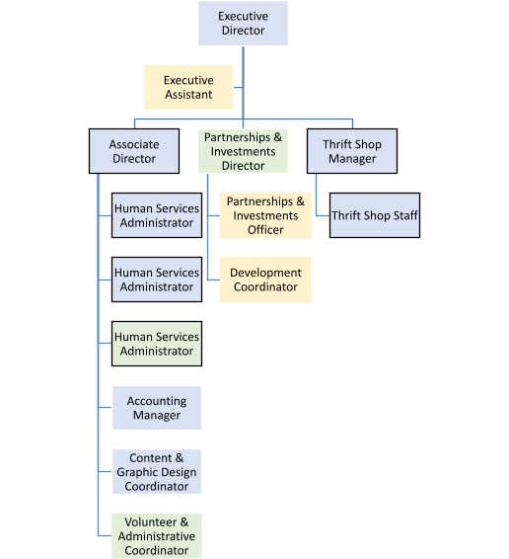

**Bellevue LifeSJJring Financial Projection**

|  |  |  |  |  |  |  |
| --- | --- | --- | --- | --- | --- | --- |
|  | **2018-19** | **2019-20** | **2020-21** | **2021-22** | **2022-23** | **2023-24** |
| **Revenues** | **Actual** |  |  |  |  |  |
| **Contributed Income** |  |  |  |  |  |  |
| Events |  |  |  |  |  |  |
| *Luncheon* | 372,600 | 400,000 | 420,000 | 441,000 | 463,050 | 486,203 |
| *Uncork The Night* | 534,019 | 533,250 | 335,000 | 351,750 | 369,338 | 387,804 |
| *Cbmmunity* | 70,000 | 50, 00 0 | 55,000 | 57,750 | 60,638 | 63,669 |
| *Member Circles* | 39,000 | 41,500 | 49,800 | 59,760 | 62,748 | 65,885 |
| *Events subtotal* | *1,015,619* | *1,024,750* | *859,BGG* | *910,260* | *955,773* | *1,003,562* |
| Individuals | 289,318 | 518,940 | 700,569 | 945,768 | 1,276,787 | 1,723,662 |
| Foundations | 45,000 | 75,000 | 101,250 | 131,625 | 171,113 | 222,446 |
| Corporations | 105,000 | 165,000 | 288,750 | 389,813 | 526,247 | 710,433 |
| Gov't Agencies |  |  |  | 80,000 | 80,000 | 120,000 |
| *Contributed income subtotal* | 1,454,937 | 1,783,690 | 1,950,369 | 2,457,466 | 3,009,919 | 3,780,104 |
| *Eamed Income subtotal* | 212,500 | 220,000 | 231,000 | 242,550 | 254,678 | 267,411 |
| *In-kind subtotal* | 270,000 | 270,000 | 283,500 | 297,675 | 312,559 | 328,187 |
| **Total Revenues** | **1,937,437** | **2,273,690** | **2,464,869** | **21}97,691** | **3:;77,156** | **4,375,702** |
| **ExJJenses** |  |  |  |  |  |  |
| **Staff ExJJeme** |  |  |  |  |  |  |
| Management & Operations |  | 159,483 | 167,457 | 215,830 | 226,622 | 237,953 |
| Program Deli very |  | 188,192 | 259,762 | 272,750 | 286,388 | 300,707 |
| Thrift Shop |  | 95,531 | 99,412 | 103,470 | 107,712 | 112,148 |
| Partnerships & Investments |  | 19 7 951 | 22 6 599 | 277 929 | 291 825 | 306 417 |
| *Salaries subtotal* |  | 641,157 | 753,230 | 869,979 | 912,547 | 957,224 |
| Misc Payroll Costs |  | 2,425 | 2,910 | 3,492 | 4,190 | 5,028 |
| Professional Development |  | 2,250 | 2,700 | 3,240 | 3,888 | 4,666 |
| Benefits (6%) |  | 38,000 | 45,194 | 52,199 | 54,753 | 57,433 |
| Payroll Taxes (12.5%) |  | 80,145 | 94,154 | 108,747 | 114,068 | 119,653 |
| *Staff Expense subtotal* | 590,000 | 763,977 | 898,188 | 1,037,657 | 1,089,446 | 1,144,005 |
| **Programs** - **SJJecial Assistance** |  |  |  |  |  |  |
| Feed (50%) | 201,150 | 274,400 | 287,417 | 444,900 | 698,370 | 1,027,718 |
| dothe (12%) | 68,995 | 67,500 | 68,980 | 106,776 | 167,609 | 246,652 |
| Educate (18%) | 112,520 | 97,560 | 103,470 | 160,164 | 251,413 | 369,978 |
| Emergency (20%) | 89,751 | 108,000 | 114,967 | 177,960 | 279,348 | 411,087 |
| *Programs subtotal* | 472,416 | 547,460 | 574,833 | 889,800 | 1,396,739 | 2,055,435 |
| **Professiona** I **Services** |  |  |  |  |  |  |
| Accounting/Bookkeeping | 32,000 | 10,250 | 10,763 | 11,301 | 11,866 | 12,459 |
| Event Services |  |  | 25,000 | 26,250 | 27,563 | 28,941 |
| Grant Writing & Research |  |  | 10,000 | 10,500 | 11,025 | 11,576 |
| Legal Fees |  | 250 | 263 | 276 | 289 | 304 |
| Management Consulting | 21,250 | 75,000 |  |  |  |  |
| Training |  | 2,000 | 2,400 | 2,880 | 3,456 | 4,147 |
| *Professional Services subtotal* | 53,250 | 87,500 | 48,425 | 51,206 | 54,199 | 57,427 |
| **OJJerations** |  |  |  |  |  |  |
| Advertising & Marketing | 15,400 | 2 0, 00 0 | 21,000 | 22,050 | 23,153 | 24,310 |
| Bank Charges | 23,200 | 24,000 | 25,200 | 26,460 | 27,783 | 29,172 |
| Board Meetings & Retreat | 7,200 | 6,000 | 6,300 | 6,615 | 6,946 | 7,293 |
| Business Taxes (Thrift Shop) | 21,820 | 2 0, 30 0 | 21,315 | 22,381 | 23,500 | 24,675 |
| Computers/Web Hosting/IT | 20,000 | 15,000 | 15,750 | 16,538 | 17,364 | 18,233 |
| Event Expense | 219,220 | 236,355 | 248,173 | 260,581 | 273,610 | 287,291 |
| In-kind Expenses | 270,000 | 270,000 | 283,500 | 297,675 | 312,559 | 328,187 |
| Insurance - Liability, D&O | 10,034 | 11,000 | 11,550 | 12,128 | 12,734 | 13,371 |
| Misc Expense | 22,000 | 18,855 | 19,798 | 20,788 | 21,827 | 22,918 |
| Postage & Ma iii ng Services | 2,400 | 2,400 | 2,520 | 2,646 | 2,778 | 2,917 |
| Printing & Copying | 8,000 | 8,000 | 8,400 | 8,820 | 9,261 | 9,724 |
| Rent: Bellevue Square Fees | 49,475 | 51,936 | 54,533 | 57,259 | 60,122 | 63,129 |
| Rent: Office Space | 65,287 | 6 6,609 | 69,939 | 73,436 | 77,108 | 80,964 |
| Rent: storage | 4,069 | 4,586 | 4,815 | 5,056 | 5,309 | 5,574 |
| Rent: Utilities | 8,407 | 9,500 | 9,975 | 10,474 | 10,997 | 11,547 |
| Repairs/Maintenance | 5,520 | 6,240 | 6,552 | 6,880 | 7,224 | 7,585 |
| Supplies, Equipment & Furnishings | 8,000 | 9,500 | 9,975 | 10,474 | 10,997 | 11,547 |
| Telephone & Communications | 11103 | 9 500 | 9 975 | 10 474 | 10 997 | 11 547 |
| *Operations subtotal* | 771,135 | 789,781 | 829,270 | 870,734 | 914,270 | 959,984 |
| **Total ExJJenses** | 1,886,801 | 2,188,718 | 2,350,716 | 2,849,397 | 3,454,654 | 4,216,851 |
| **NET INCOME** | 50,636 84,972 114,153 148,294 122,502 158,851 | | | | | |

**Business Plan Highlights**

# EXECUTIVE

**SUMMARY Our Mission:** Bellevue LifeSpring’s mission is to foster stability and self-sufficiency for Bellevue’s children and their families through programs that provide food, clothing, education and emergency assistance.

**Our Vision:** We envision a Bellevue where the basic needs of all children are being met so they can focus on their education and break the cycle of poverty in our community.

**The Challenge:** Many are shocked to discover poverty exists in Bellevue. Today more than 3,600 children in Bellevue qualify for free and reduced priced school meals. Even more families struggle to get by with our region’s high cost of living. Approximately 300 students are experiencing homelessness. This income gap impacts educational achievement and the long-term chances for children to break out of the cycle of poverty. The Bellevue School District reports that children living in poverty experience achievement gaps of 35% in reading and 49% in math. Low-income students also graduate at a lower rate: 91% versus 95% for the student body as a whole. That number drops to 81% for students experiencing homelessness.

**Why Us:** Bellevue LifeSpring has been doing this work for more than 100 years. As Bellevue’s first human services organization, we have deep and established roots in supporting families with children in Bellevue with comprehensive services. Our longstanding partnership with the Bellevue School District ensures we deliver programs directly to the children in need of support.

**Our Goal:** Ensure that all students in Bellevue have the food, clothing, housing assistance and educational support they need to achieve and graduate at the same rate as their peers by 2025.

**Our Strategies:** In order to reach ALL children living in Bellevue, we will:

* Support every child’s basic needs – food, clothing and housing assistance – over the long term, focusing on those that qualify for the Federal Free & Reduced Price Lunch program.
* Fund summer school and credit recovery programs for high schoolers.
* Be the voice for children and their families in Bellevue.

To achieve this we need to double our annual operating budget from $2.1 million to $4.2 million in five years. The payback for Bellevue is both stable families and a potential $65 million savings in state resources.

Bellevue LifeSpring Business Plan – CONFIDENTIAL DRAFT v. 09.26.2019

19