treehouse

**giving foster kids a childhood and a future**

Treehouse Plan

DRAFT for discussion purposes only Version 1.4

SUMMARY Treehouse has worked tirelessly for 25 years to enrich the lives of foster children. Eighteen years ago, we identified the need for educational support that recognizes and responds to the unique needs of children in foster care. Experiencing a crisis in parenting creates a great number of obstacles to educational success, and leads to a sobering outcome: foster children graduate from high school at half the rate of their peers.

Now, with all we have learned, we have an incredible opportunity to do more to help our most vulnerable children. With fierce optimism, Treehouse is investing in the lives of young people who have been impacted by foster care. By securing the opportunities they equally deserve, we are heIping them buiId their Iives and prosper.

Treehouse is joining each of our services into a model that identifies the research-based points at which we can move foster children to high school graduation and a successful future. Through ***Graduation*** *Success,* Treehouse's comprehensive educational support initiative, **foster children in King County will graduate at the same rate as their peers with a plan for their future by 2017.**

The core program model for *Graduation Success* is *ABC Plus,* which summarizes the six factors that lead to high school graduation:

1. Regular class **attendance;**
2. Good **behavior;**
3. **Course performance; *plus***
4. Extra-curricuIar activities;
5. A mindset of persistence and perseverance; and
6. A student-centered plan for the future.

Our Education Specialists provide a critical stable adult presence in each child's life, partnering with social workers, caregivers, and schools, monitoring *ABC Plus* progress, and serving as the "quarterback" of a network of support.

This year, Treehouse has expanded to serve every foster child in the expected graduation class of 2017 - current 8th graders - working to get them on track to graduate. We will expand services each year so that five years from now, Treehouse will serve every 6th - 12th grade foster child in King County - 830 in total.

This plan provides a high-level look at Treehouse's forward direction, serving as a guide for the agency, an invitation for feedback, and an opportunity for partnership with all those who can help Treehouse and the vulnerable youth we serve succeed.

# BACKGROUND

GOAL

Treehouse's mission is to give foster kids a childhood and a future. We were founded in 1988 by soc iaI workers who saw the deprivation often faced by children in foster care. They held bake sales and car washes to provide things that help children feel loved and special.

These efforts have bIossomed. With the support of tens of thousands of generous donors and partners across our community, Treehouse provides clothes, toys, and school supplies at our Wearhouse, and access to crit icaI extracurricuIar activities and community resources through our Little Wishes program - bringing support to thousands of children in foster care each year.

Treehouse is now a major partner with the child welfare system, providing innovative whole-child development programming that is buiIt on what experience and research says works. Over the years, we have pilated a wide range of education support services: tutoring, educational advocacy, college and career planning, and learning centers around King County. We align ourselves with collective impact and education reform efforts such as the Youth Development Executives of King County and the Road Map Project. Despite these efforts, high school graduation rates of youth in foster care have continued to lag behind the general population.

As we prepare to celebrate our 25th year, we are embarking on our most important work yet. Foster kids drop out of high school at alarmingly high rates: less than half of youth in the foster care system graduate from high school on time, compared to 80% of their peers.1 Research teIls us that this Iack of education leads to further problems: nearly 25% of those leaving foster care wi11 be homeless as adults;2 80% wi11 Iive below the poverty Iine; and more than 30% will receive public assistance.3

Building on our 25 years of practice and the best research available, Treehouse is harnessing our experience, expertise, and fierce optimism to address this problem in an efficient, scalable, and replicable manner.

Treehouse wi11 continue to provide critical support and enrichment services to thousands of children each year. Our educational support program, ***Graduation Success,*** will do whatever it takes to achieve our goal: **foster children in King County will graduate at the same rate** as **their peers with a plan for their future by 2017.**

1 Washington State Institute for Public Policy (2009).

*2* Casey Family Programs (2005).

3 Chapin Hall Center for Children (2004).

Improving graduation rates to this extent means that Treehouse must reach and successfully support students attending more than

100 schools across 17 school districts. This amounts to one of the largest efforts to move foster children toward educational success.

Neither chi Id welfare nor school systems alone can focus on the specialized educational needs of foster children. Treehouse is uniquely placed between these two systems and fiercely committed to better educationaI outcomes.

Beginning with the expected graduation class of 2017 - this year's 8th graders - Treehouse will partner with every middle school in every district in King County to get these children on track to graduate. We will add cohorts and expand services each year so that in five years, Treehouse will serve every child who has been in foster care in 6th - 12th grade - 830 in total. Further, Treehouse will continue to support thousands of children statewide, providing shorter-term educational advocacy interventions as well as the hope and aspiration of our holiday gift program.

With strong evidence of success, the *Graduation Success* model can be repIicated throughout Washington State and beyond. Treehouse's existing statewide programming and nationaI stature can support future expansion as evidence and resources aIlow.

SOLUTION

Research, years of practice, and evaluation have guided us today to the core program model for *Graduation Success,* one we call ***ABC Plus.*** This program combines education planning, monitoring, coaching, and support led by a Treehouse Education Specialist.

*ABC Plus* summarizes the six factors that lead to a successful high school graduation. The first three are tracked by schools:

* A is for regular class attendance
* B is for good behavior
* C is for adequate course performance

The "plus" in our model refers to additional critical attitude and engagement measures that research and practice have identified as critical elements we must also support for foster children's graduation:

* Meaningful participation in an extra-curricular activity
* A sense of engagement, belonging, and self-determination
* A student-centered plan for the future4

4 University of Chicago Consortium on Chicago School Research (2012).

If we can ensure that each child achieves positive indicators in each of these areas - if each child is on track with the "plus" as well as the ABCs of school - then they will succeed.

Treehouse's *Graduation Success* model delivers customized interventions and support to help every child succeed in every one of these six areas of focus. First, each student we serve is at the center of our services. Every child works with a Treehouse Education Specialist, a trained professional who makes sure that she receives appropriate, rapidly delivered supports and services tailored to her individual developmental needs.

Our Education Specialists begin by partnering with social workers, caregivers, and an in-school mentor to create a portrait of each youth's needs. Then, the Specialist gets to know each child through ongoing, supportive meetings. Together they create a student­ centered plan to define educational needs and aspirational goals.

The Specialist then works with each student and an in-school team to man itor *ABC Pl us* progress and choose appropriate intervent ians and supports from Treehouse and the community network of services. Formal partnerships with the state and school districts Ieverage addition aI support and informati on-sharing.

Treehouse provides unique services such as the Wearhouse, which provides free clothing and school supplies, and Little Wishes, which funds extra-curricular engagement and additional learning opportunities. We also give every child in foster care a holiday gift to reinforce the positive feeling of being valued, loved, and cared for.

We actively leverage dozens of community partners and volunteers, seeking to deliver services only where we are uniquely positioned and qualified for maximum impact. When students need specialized services that partners can provide, such as tutoring, counseling, and formaI colIege preparation activities, the Education Spee iaIist connects the student and monitors progress.

The Education Specialist is the year-round "quarterback" of this network of support, providing ongoing coaching to foster a positive mindset and drive progress towards meeting the goals in the navigation plan.

When the Education Spee iaIist sees that one of the six *ABC Plus* measures is not on track - perhaps there is prolonged absence from school or poor grades - the Specialist is there with best-practice

support and intervention. A welI-timed meeting involving alI the providers and family members in a youth's life can change the trajectory from fai Iure to success. Specialists also engage community partners for, say, the support to participate in sports or an internship. Or it may mean guiding them and caregivers to appropriate counseling and mental health services.

In situations where a more emergent need arises - sueh as a behavior issue that leads to suspension or other time out of class - Treehouse uses its tested Educational Advocacy intervention to prevent or reduce time out of class and keep kids in school.5

Whatever the need, the Education Specialist guides a collective effort that surrounds each chi Id with critical resources, each of which has a role in helping the student achieve success:



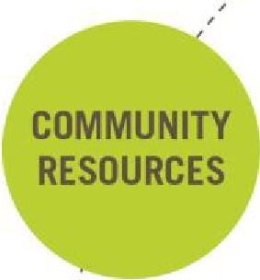,,, �-

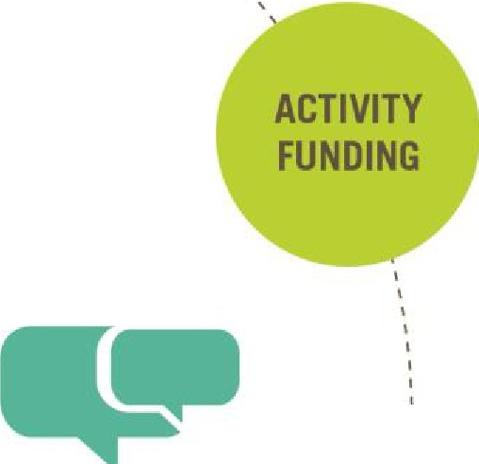'·,, ',,_

**TREEHOUSE** , ,

''

•



**CAREGIVER**

'

I

''

'

'

**t**

**FOSTER YOUTH**



**SCHOOL**

**SOCIAL WORKER**

'

I

'

'''

I ''

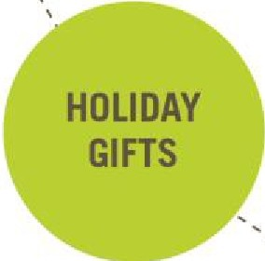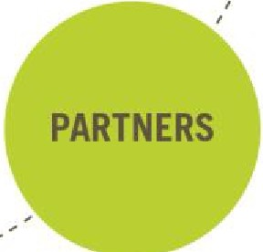I

� This Treehouse-developed, short-term solution is now included in the California Clearinghouse for Evidence-Based Programs in Child Welfare as a promising practice.

GETTING TO SCALE This year, *Graduation Success* will reach 400 youth in King County, most of whom are in districts with the lowest graduation rates. We are now expanding to serve every 8th grader in foster care in King County, increasing our school

partners from 26 schools in 7 districts to more than 60 schools in 17 districts. We'll be adding a new 8th grade cohort each year, and drawing in the remainder of foster students at a rate of 100-150 new children each year. By 2017, we'll serve 830 students in all 17 school districts in King County.

**Students Served**

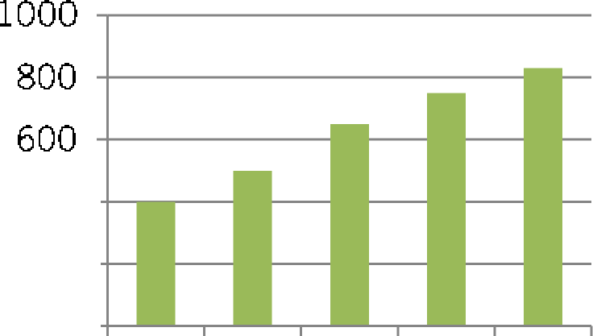

400

200

0

2013 2014 2015 2016 2017

We already engage the vast majority of foster children and their caregivers through our free store (The Wearhouse) and extracurricular engagement program (Little Wishes), so we wi11 continue to provide these important keys to success at similar levels. Our saturation levels are already near targeted capacity for these services, which result in a "pipeline" of engagement with Treehouse. This year they'll serve nearly 2,000 youth, with an eye on providing clothes that help kids fit in and activities that are high­ quaIity and high-engageme nt - exactly what research suggests they need. We expect 5% annual growth in the number served through these efforts. Our statewide targeted Educational Advocacy and our holiday gift program are already at scale across Washington, serving *lAOO* and nearly 5,000 children and youth respectively.

PERFORMANCE

We track a range of key performa nee indicators on overa 11 capacity, student performance toward graduation, and the impact of each team on the students they serve, as shown in Attachment B.

Our capacity measures include the number of students served by:

* *Graduation Success*
* Statewide *Educational Advocacy*
* Enrichment - *Little Wishes, Wearhouse, Holiday Magic*

Student performance tracking captures:

* Graduation rates
* Students "on track to graduate" - they have the grades and course credits to lead them to graduation
* The six *ABC Plus* factors

Finally, we track the performance of each Education Specialist and each geographic team. Each week, Speci aIists record every student support and intervention they deliver - there are many possi biI ities depending on the needs of the student. Each month, quarter, and year, each team reviews student and operational data and confers with leadership to ensure fidelity of program delivery, adherence to best practices, and positive movement of graduation indicators.

Our programs are based on best practices and research, but we expect th at our rich performa nee data wi11 highIight where additi onaI focus and innovation is needed. We have identified areas where we must develop either internal expertise or formal partnerships: intensive academic remediation and engaging more effectively as partners with caregivers.

RESOURCES

CONCLUSION

None of the progress Treehouse has made over the past 25 years would have been possible without the tens of thousands of individuals and businesses who have given so generously. Today, Treehouse is a financially sound, well-managed organization that is prepared to take on a challenge of this significance.

Moving forward, we will seek to grow our annual revenue from

$7.7M in 2013 to approximately $10.5M by 2017 to meet the needs of our enrichment programs-Little *Wishes, Wearhouse,* and others-as well as the build-out of *Graduation* Success. We have strengthened our leadership giving program, modeling our strategy on the most effective and transparent organ izat ians.

Today, *Graduation Success* costs $6,000 per child to implement. This cost may vary as the program grows and we gain further experience, identify efficiencies, and continue to refine programming based on research and evaluation. We expect technology to play a role in program refinement, including using social media, gaming strategies, and smartphone applications to enhanee our abiIity to connect with, monitor, and mentor chi Idren.

The benefit to our community from *Graduation Success* extends far into the future. We know that over the course of their lifetime, a student who draps out of high school wi 11 cost an addition al

$292,000 in services, treatment, and lower productivity. The average high school graduate earns $10,000 more every year than their peers who don't complete high school. Our foster children deserve the opportunity to achieve success.

We will continually revise this plan as we test, evaluate, and refine our model. Furthermore, as we gather evidence of our program's impact, we will study its potential for broader replication.



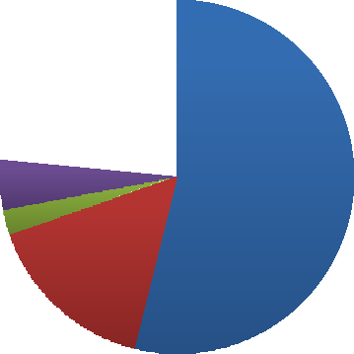





# ATTACHMENT B

Program Evaluation Model

The table below provides the major categories for data collection and evaluation to monitor and measure the impact of *Graduation Success.* Internally, Treehouse monitors program capacity annually and Program Performance and Service delivery each month, quarter, and year as appropriate.

**REPORT CATEGORY REPORT SUBJECT**

1. **Program Capacity**
2. **Program Performance**

A.l. Total Youth Served

A.2. Graduation Success Program Expansion

A.3. Enrichment Services

A.4. Statewide Services

* 1. Graduation Performance
  2. On-Track To Graduate Rates

8.3. ABC Plus

a. Attendance Performance

b. Behavior Performance

1. Course Performance
2. Extra-Curricular Engagement
3. Mindset
4. Plan for the Future
5. **Service Delivery**

C. l. Service Delivery By Geographic Team

C.2. Service Delivery By Educational Specialist

# ATTACHMENT C

TREEHOUSE ORG CHART

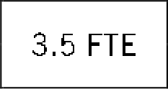

Chief Executive Officer Janis Avery

Chief Operating Officer Dawn Rains

Statewide Advocacy, Training

'-9-FT_E-'I I

Leadership Giving, Foundations, Events, Annual Fund, Holiday Magic, Volunteers

17 PT

In-School Mentors

Evaluation, Quality Assurance

Wearhouse, Little Wishes, Summer Camp

Treehouse Learning Center, Outreach, Education Volunteers, Credit Retrieval

3 Teams

60 Schools

7 Districts

400 Youth

Information Technology, Payroll

1.25 FTE I I 17 FTE I I 6.25 FTE I I 13.5 FTE I I 6.5 FTE I I 2 FTE

Contract Services

Sr. Mgr, Human Resources Ann Hanni

Director of Admin & Finance

Darrel I PowelI

Exec. Supp. 1 FTE

Sr. Mgr, Marketing & Communication Sarah Kurtzman

Sr. Mgr, Education Services Angela Griffin

Sr. Mgr, Education Program Operations Lynda Hall

Sr. Mgr, Ed. Advocacy Statewide Shanna McBride

Sr. Mgr, Enrichment Programs Jennie Trzyna

Sr. Mgr, Impact Meas. Robin Harwick

Director of Dev.

Jessica Ross

# ATTACHMENT D

|  |  |  |  |  |  |  |
| --- | --- | --- | --- | --- | --- | --- |
| FIVE-YEAR | FINANCIAL PROJECTION |  | | | | |
|  |  | **2013 2014 2015 2016 2017** | | | | |
| **REVENUE** |  |  |  |  |  |  |
|  | Individuals | 4,128,000 | 4,560,540 | 5,048,540 | 5,597,217 | 6,096,828 |
|  | Corporations | 200,000 | 250,000 | 300,000 | 325,000 | 350,000 |
|  | Foundations | 1,100,000 | 1,200,000 | 1,300,000 | 1,375,000 | 1,425,000 |
|  | Contracts & Earned Income | 855,000 | 880,000 | 880,000 | 880,000 | 880,000 |
|  | In-Kind Goods | 1,453,500 | 1,525,000 | 1,600,000 | 1,675,000 | 1,750,000 |
| **Total Revenue** |  | **7,736,500** | **8,415,540** | **9,128,540** | **9,852,217** | **10,501,828** |
| **EXPENSES** |  |  |  |  |  |  |
|  | Personnel* | 4,190,711 | 4,662,661 | 5,088,861 | 5,443,304 | 5,820,469 |
|  | Operating | 1,232,898 | 1,374,898 | 1,524,898 | 1,675,000 | 1,825,000 |
|  | Events | 175,250 | 100,250 | 105,000 | 110,000 | 115,000 |
|  | Holiday Magic Gift Purchases | 350,000 | 358,540 | 373,540 | 392,217 | 411,828 |
|  | Scholarships & Grants | 371,900 | 390,500 | 410,000 | 430,000 | 451,500 |
|  | Extern aI EvaIuation | 0 | 0 | 0 | 125,000 | 125,000 |
|  | In-Kind Goods | 1,453,500 | 1,525,000 | 1,600,000 | 1,675,000 | 1,750,000 |
| **Total Expenses** |  | **7,774,259** | **8,411,849** | **9,102,299** | **9,850,521** | **10,498,797** |
| ***NET*** |  | **-37,759** | ***3,691*** | ***26,241*** | ***1,696*** | ***3,031*** |
| **YOUTH SERVED** |  |  |  |  |  |  |
|  | ***Graduation Success*** | ***400*** | ***500*** | ***650*** | ***750*** | ***830*** |
|  | ***Statewide Advocacy*** | ***1100*** | ***1100*** | ***1100*** | ***1100*** | ***1100*** |
|  | ***Extracurricular*** & ***Clothing*** | ***1950*** | ***2050*** | ***2150*** | ***2275*** | ***2375*** |
|  | ***Holiday Magic*** | ***4700*** | ***4700*** | ***4700*** | ***4700*** | ***4700*** |

*Personnel line includes addition of 10.0 FTE (2 new geographic teams composed of **4** Education Specialists and a Team Lead) total in 2014 and 2015, followed by smaller increases of 2.0 FTE per year in 2016 and 2017 to reach fu 11 capacity